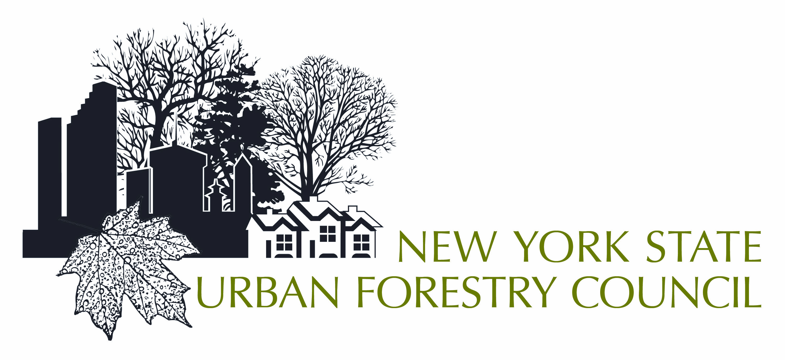

2018 Arbor Day Community Grant Notice

The NYS Urban Forestry Council is pleased to announce available funding for small communities to have a 2018 Arbor Day tree planting event and to establish a community based forestry program. This funding has been provided by the USDA Forest Service and the NYS DEC Urban Forestry Program (and is NOT associated with the Arbor Day Foundation nor is part of the NYS DEC EPF community grants program).

Grants of up to $1,000 will be awarded to communities or non-profits (that work in partnership with communities) to celebrate Arbor Day 2018 by both planting a tree (or trees) … and forming a volunteer tree committee or tree board within the municipality. To be considered for a grant, please complete and return the enclosed application and requested documentation.

Besides planting trees, the intent of this grant is to help promote and establish a meaningful community forestry program. Communities that are currently a Tree City USA or those that have any component of the Tree City USA program, such as a tree ordinance, tree board, tree inventory or management plan are ineligible. Previous NYS Arbor Day Community Grant recipients are also ineligible.

Applications will be scored competitively and awarded from highest to lowest until the funding is exhausted. 50% of the amount awarded will be paid to the awardees upon return of a signed grant acceptance form and required documents. The remainder of the grant will be paid once a final report (brief summary of event, photos, receipts for expenditures and copies of materials related to the establishment and goals of a tree committee or board), is submitted.

Eligible expenses may include (but are not limited to) trees, mulch, soil, stakes (if necessary for the site), printing of a program and advertising to publicize the event. Values for in-kind or in-house labor, equipment, supplies, etc. can be included as part of your budget. Please refer to the enclosed recommended resources to facilitate tree species selections and feel free to contact committee members if you have questions.

Applications are due by 8 PM, February 28, 2018 (see attached) and award recipients should be notified by the third full week of March.

Thank you for your interest in trees and improving the environment within your community.

Sincerely,

Karen Emmerich, President
Brian Skinner, Treas. & Committee Chair

New York State Urban Forestry Council
PO Box 562, Lima, NY 14485
nysufc@gmail.com

Resources For Arbor Day Community Grants

NYS Urban Forestry/Arbor Day Community Grant Committee Members

Andrew Hillman, UFC Past President Brian Skinner, UFC Treas.
NYS Urban Forestry Council NYS Urban Forestry Council
607-339-3968 315-436-6053
andrew.hillman@davey.com bskinner002@twcny.rr.com

Lori Brockelbank Terry Hawkridge
NYS Urban Forestry Council NYS Urban Forestry Council
716-450-0884 315-525-2097
lbrockelbank@gmail.com l.d.terryhawkridge@gmail.com

Mary Kramarchyk Karen Emmerich, UFC President
NYS DEC – Urban Forestry Freshwater Environ. Consultants, LLC
518-402-9428 914-850-2667
mary.kramarchyk@dec.ny.gov karenemmerich77@gmail.com

Jeffrey Bell Eric Greenfield
NYSEG USDA Forest Service
585-484-5284 315-448-3214
jebell@nyseg.com ejgreenfield@fs.fed.us

Resource Websites

- NYS Urban Forestry Council (questions, contacts, references) http://nysufc.org

- Tree Planting resources: (tree species selections, planting suggestions)
http://www.hort.cornell.edu/uhi/outreach/recurbtree/pdfs/~recurbtrees.pdf

- Cornell University, Urban Horticulture Institute website (tree species info, planting suggestions) http://www.hort.cornell.edu/uhi/

- Arbor Day Foundation (tree species info, starting tree boards, Arbor day programs)
http://www.arborday.org/

- NYS DEC (Regional offices, contacts, etc.) http://www.dec.ny.gov/about/558.html

- National Grid’s “10,000 Trees…and Growing” program (tree species, planting suggestions)
https://www.nationalgridus.com/media/pdfs/safety/cm4494_treesafety.pdf

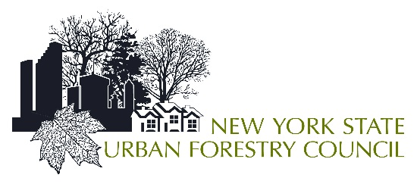Application For Arbor Day Community Grant
All applications are due no later than 8 PM, February 28, 2018!
Name of Municipality or applying entity: __________________________________________

Project Contact: _____________________________________________________________

Address: ___________________________________________________________________

Email & Phone: ______________________________________________________________

Municipal or non-profit fiscal contact: ____________________________________________

Address: __________________________________________________________________

Email & Phone: _____________________________________________________________

Municipal Chief Elected official: ____________________________________________
Signature of official: __________________________________________________________

PLEASE PROVIDE:
- Date of Arbor Day Event: __________________________________ (Please note that your Arbor Day event date is not limited to the official NYS Arbor Day which is the last Friday of April)
- Participants: List potential participants and how you will involve the public in this event.

- Description of Project: Include a brief description of your proposed project and why you should receive this grant. Include a list of trees to be planted. If you contact an Arbor Day Grant Committee member, ISA Certified Arborist, NYS Nursery/Landscape Assn. Certified Nursery Professional or a regional NYS DEC forester for assistance to confirm the appropriateness of your tree selection, let us know who, their title and when contacted.

- Tree Committee/Board: Describe how your newly formed committee/board will function, possible meeting dates, possible committee members and roles.
- Photos: Please include 1-4 pictures representative of the site(s) where you will be planting.
- Budget: List estimated costs of trees and/or other necessary supplies and expenses (NOTE: In-kind community labor, equipment or supplies values should be included, if used).
- Municipal Resolution: A resolution must be submitted (once awarded a grant) from the government entity where this project will be located. Sample resolutions are provided.

Applications should be sent to:

NYS Urban Forestry Council, PO Box 562; Lima, NY 14485
or via email to nysufc@gmail.com; phone 585-624-3385

(Note: Do NOT wait till the last minute! Applications received after the due date/time for any reason are ineligible. We strongly suggest you contact the office by phone / email to confirm receipt of your materials.)
Sample Resolutions (To be submitted with grant acceptance contract at time of award)
Sample Resolution of Support:
A resolution in the general format provided below must be passed at an official meeting of the governing body of the applicant. The original resolution, or a letter of intent to provide such prior to contract execution, must accompany the completed application. The resolution must be typed on the applicant’s stationery, should have an original signature, and should hold the official seal (if available). The name of the applicant must be stated as it is recorded in the incorporation documents. Use the appropriate phrase in bold or brackets, depending on whether the applicant is a not-for-profit corporation, or municipality, respectively.

Authorizing Resolution:
I, Name , Title (Secretary, Notary) of the Village or City or Organization of Place , New York, do hereby certify that the following resolution was adopted at a Regular or Special meeting of the Governing body or Village Board or Board of Directors held on (Date) , and is (incorporated in the original minutes of said meeting) or (on file and of record), and that said resolution has not been altered, amended or revoked and is in full force and effect.

RESOLVED:
That Official’s Name, as Title of Village or City or Organization (Applicant), or such person's successor, is hereby authorized and directed to file an application for an Urban Forestry Council Arbor Day Program Community Grant in an amount not to exceed $ 1,000 and upon approval of said request to enter into and execute a project agreement with the New York State Department of Environmental Conservation for such financial assistance to (City or Town or Organization Name) for (grant project name). (Signature of Secretary) OR (Signature of Clerk)
Seal of Organization (if unavailable-notarization is required) Seal of Municipality
++++++++++++++++++++++++++++++++++++++++++++++++++
Sample Municipal Endorsement:
The Municipal Endorsement is for non-municipal projects located on municipal property and must accompany the completed application. (Acceptable municipal endorsement for use when applicant is not a municipality.)
Resolution No. __________

WHEREAS, the (applicant name) is applying to the New York State Urban Forestry Council for an Arbor Day Program Community Grant to be located (insert location), a site located within the territorial jurisdiction of this (Board, Council or Legislature); and
WHEREAS, as a requirement of these programs, said (type of applicant) must obtain the “approval/endorsement of the governing body of the municipality in which the project will be located”,
NOW, THEREFORE, be it resolved that the (Board, Council or Legislature) of (municipality) hereby does approve and endorse the application of (applicant name) for a grant from the NYS Urban Forestry Council for an Arbor Day Program Community grant project and located within this community.
(Date of Adoption and Certification of Clerk)

